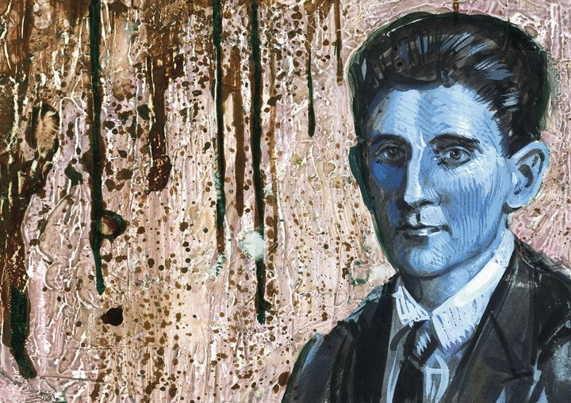

Kafkaesque
Named after the author Franz Kafka, typically used to describe anything that makes no sense and has no points of reference.
Waking up and being a human sized insect but being able to fit under a regular door and subsequently kicked by your father. THAT'S Kafkaesque.

Kafkaesque
Comes from the author Franz Kafka, and refers to the style with which he wrote his books (which in his dying wish asked for them to be burned).
Basically it describes a nightmarish situation which most people can somehow relate to, although strongly surreal, with an ethereal, "evil", omnipotent power floating just beyond the senses.

Kafkaesque
Describing something that is horribly complicated for no reason, usually in reference to bureaucracy. Named after the early 20th century writer Franz Kafka, best known for "The Trial" and "Metamorphosis".
Kafkaesque
According to the Merriam-Webster dictionary:
of, relating to, or suggestive of Franz Kafka or his writings; especially : having a nightmarishly complex, bizarre, or illogical quality

Bottom of Form
Franz Kafka (1883-1924) was a Czech-born German-language writer whose surreal fiction vividly expressed the anxiety, alienation, and powerlessness of the individual in the 20th century. Kafka's work is characterized by nightmarish settings in which characters are crushed by nonsensical, blind authority. Thus, the word Kafkaesque is often applied to bizarre and impersonal administrative situations where the individual feels powerless to understand or control what is happening.

Kafkaesque
According to Ivana Edwards in the New York Times archive

SO just what does this adjective "Kafkaesque" mean? And why does Frederick R. Karl, author of an exhaustive critical biography of Franz Kafka, believe that the word is as misused as it is used?

Kafka is the only 20th-century literary figure whose name "has entered the language in a way no other writer's has," Mr. Karl says. But "what I'm against is someone going to catch a bus and finding that all the buses have stopped running and saying that's Kafkaesque. That's not."
"What's Kafkaesque," he said in an interview in his Manhattan apartment, "is when you enter a surreal world in which all your control patterns, all your plans, the whole way in which you have configured your own behavior, begins to fall to pieces, when you find yourself against a force that does not lend itself to the way you perceive the world.
"You don't give up, you don't lie down and die. What you do is struggle against this with all of your equipment, with whatever you have. But of course you don't stand a chance. That's Kafkaesque.

What Does ‘Kafkaesque’ Mean, Anyway?

By Claire Fallon in Huffington Post, July 1, 2016
You poor mortal fools — you thought you already knew what “Kafkaesque” meant, didn’t you? How wrong you were.

A recent TED-Ed animated video by Noah Tavlin lays it all out, explaining how we cavalierly misuse the adjective and what it really means. “Beyond the word’s casual use,” he asks, “what makes something Kafkaesque?” This TED-Ed video is the latest entrant in a long-running battle to define “Kafkaesque,” and, in a roundabout way, define Kafka’s artistic legacy. You can check out the full video on youtube:

https://www.youtube.com/watch?v=wkPR4Rcf4ww
Sure, you might be shouting at your computer or smartphone screen, we know what “Kafkaesque” is. Obviously, it means reminiscent of the themes and events found in the work of Franz Kafka, the Prague-born author whose famous stories (such as The Trial and The Metamorphosis) drew upon the soul-crushing bureaucratic machinery of the aging Austro-Hungarian empire.

We can even get more specific, though. “Kafkaesque” describes, as the Oxford Dictionaries would put it, “oppressive or nightmarish qualities,” or as Merriam-Webster suggests, “having a nightmarishly complex, bizarre, or illogical quality.”

Here’s the rub, though: Any time an author’s oeuvre becomes the basis for its own descriptor (Orwellian, Dickensian, Proustian), the meaning of that adjective depends completely on the interpretations of the original work. No matter what the dictionary says about “Kafkaesque,” the true denotation has nothing to do with dictionary entries and everything to do with what literary critics have to say about Kafka himself.

Tavlin’s own definition of “Kafkaesque” derives from reading The Trial, “A Hunger Artist,” The Metamorphosis and other Kafka works more closely, and he draws out several trademarks of his fiction beyond the idea of a baffling, illogical bureaucracy.
“It’s not the absurdity of bureaucracy alone, but the irony of the characters’ circular reasoning in reaction to it, that is emblematic of Kafka’s writing,” the video argues.
In 1991, Kafka biographer Frederick Karl offered a more limited but fairly straightforward definition to The New York Times:
What I’m against is someone going to catch a bus and finding that all the buses have stopped running and saying that’s Kafkaesque,” he said. “What’s Kafkaesque [...] is when you enter a surreal world in which all your control patterns, all your plans, the whole way in which you have configured your own behavior, begins to fall to pieces [...] What you do is struggle against this with all of your equipment, with whatever you have. But of course you don’t stand a chance. That’s Kafkaesque.”
A 2014 Atlantic “By Heart” column with author Ben Marcus, about Kafka’s “A Message from the Emperor,” claims that Marcus’s “discussion of the piece ultimately included a concise and brilliant argument for what constitutes the Kafkaesque, though he never used that word.” Instead, Marcus made arguments about what Kafka’s “quintessential qualities” were, including “affecting use of language, a setting that straddles fantasy and reality, and a sense of striving even in the face of bleakness — hopelessly and full of hope.” (If “affecting use of language” becomes one of the qualifiers for appropriately deploying “Kafkaesque,” the term will be almost impractically circumscribed.)

As Tavlin argues, “The term Kafkaesque has entered the vernacular to describe unnecessarily complicated and frustrating experiences, especially with bureaucracy. But does standing in a long line to fill out confusing paperwork really capture the richness of Kafka’s vision?”
Probably not. What does, aside from Kafka’s own brilliant and rightfully well-studied fiction? By this standard, perhaps we should only call Kafka himself Kafkaesque.

Prescriptivists who want to limit how we use terms like “Kafkaesque” are almost certainly fighting a losing battle, but there are some side benefits. For example, a quirky, thoughtful video exploring the common motifs and themes of Kafka’s fiction — that’s a worthy end in itself.

Kafka’s style
Excerpt from introduction to The Castle by Ritchie Robertson, Oxford’s World Classics pub., 2009
Though limpid, Kafka’s style is also puzzling. He was sharply conscious of the problems of perception, and of the new forms of attention made possible by media such as the photograph and cinema. When he engages in fantasy, his descriptions are often designed to perplex the reader: thus it is difficult to make out what the insect in The Metamorphosis actually looks like. He was also fascinated by ambiguity, and often includes in his fiction long arguments in which various interpretations of some puzzling phenomenon are canvassed, or in which the speaker, by faulty logic, contrives to stand an argument on its head. In such passages he favours elaborate sentences, often in indirect speech. Yet Kafka’s German, though often complex, is never clumsy. In his fiction, his letters, and his diaries he writes with unfailing grace and economy.

. . . Placing Kafka in his historical context brings limited returns. The appeal of his work rests on its universal, parable-like character, and also on its presentation of puzzles without solutions. A narrative presence is generally kept to a minimum. We largely experience what Kafka’s protagonist does, without a narrator to guide us. When there is a distinct narrative voice, as sometimes in the later stories, the narrator is himself puzzled by the phenomena he recounts. Kafka’s ﬁction is thus characteristic of modernism in demanding an active reading. The reader is not invited to consume the text passively, but to join actively in the task of puzzling it out, in resisting simple interpretations, and in working, not towards a solution, but towards a fuller experience of the text on each reading.

