The Clio: Instructions for Czech Connections, Collections, and Reflections Program

One tool we want to introduce you to is "The Clio" sponsored by Marshall University through a National Endowment for the Humanities grant. This tool allows students to write up map-pinned "entries" around some defined topic, that the instructor later joins together into a combined walking/driving "tour." For practice this April we will be creating entries around NC State University landmarks to be combined into a campus tour, and in Prague entries around the topic of Nazi/Soviet oppression to be combined into a historical tour.

Logging In  If you like this tool, you can request your own free instructor account to set up a virtual classroom space of your own. But for now, we want everyone to navigate to theclio.com, click the green Login/Register button, and then click the "Classroom Login" button.  You do not need to create a student account to access our classroom, just log-in by choosing "North Carolina State University" as the institution, "Borchardt2019" as the classroom, and "Prague" as the password with a capital letter P. When you create your entries in our classroom space, you can include your name to let us know you've created an entry. | 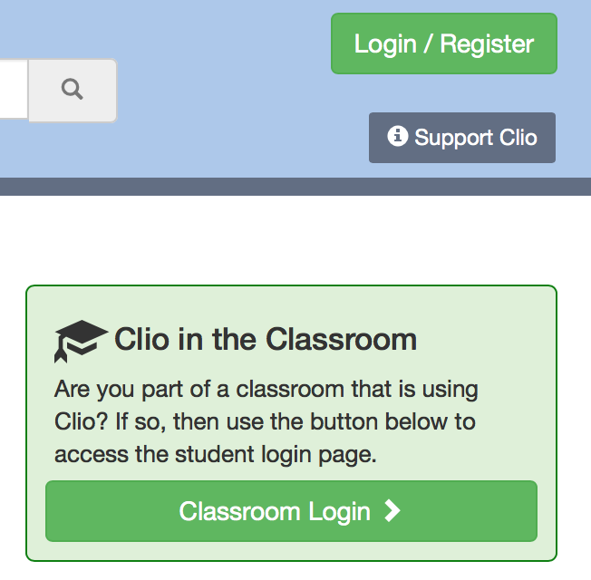  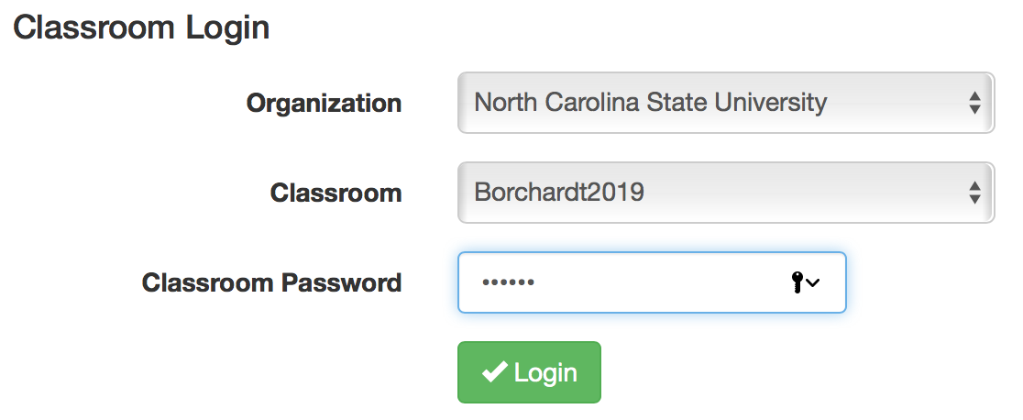

Create an Entry  The place to create an entry is a bit hidden mid-way down the page, but look for the box shown at right and click "Submit Location" to start your entry. | 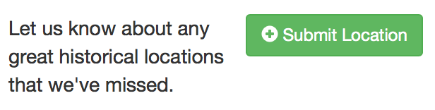
The first thing Clio will ask you for is an address to your entry. If you have a street address, you can enter it in the box provided, or if no street address is available, you can drop the star marker on the provided map. If at all possible, try to find a street address (Google search?), as this activates other features related to Google Street View, so people can view your entry as seen on Google Street View. | 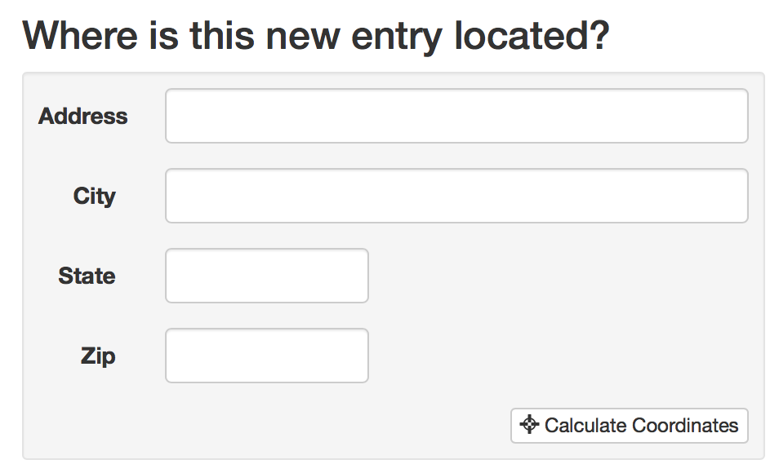
Before continuing to populate your entry, you must verify that your entry is not already in Clio. Clio does not allow duplicate entries for the same location. This will not likely be a problem for our class as only a few entries exist for Raleigh or Prague, but if you do run across a similar entry, you will need to find a different site to write about.

Provide Title, Summary Details  On the entry page, there are several fields to fill out. At the top, give your entry a title, specify the type of entry (monument/site, museum, or time capsule historic image/recollection) and then write a concise 4-8 sentence summary of your site. See example: | 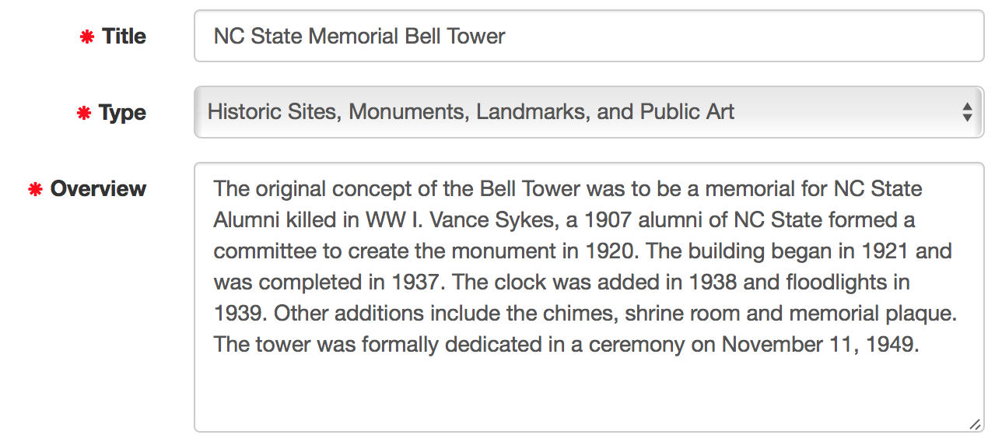
Tag Site, Add Contact Details if Applicable  After the concise description, indicate if your site is listed in one of the historical categories (national/state historic landmarks, national register), add a phone number or hours for your site if applicable, and finally add tags for your site to represent one or more types (particular type of museum, an architectural or historic building, etc.). | 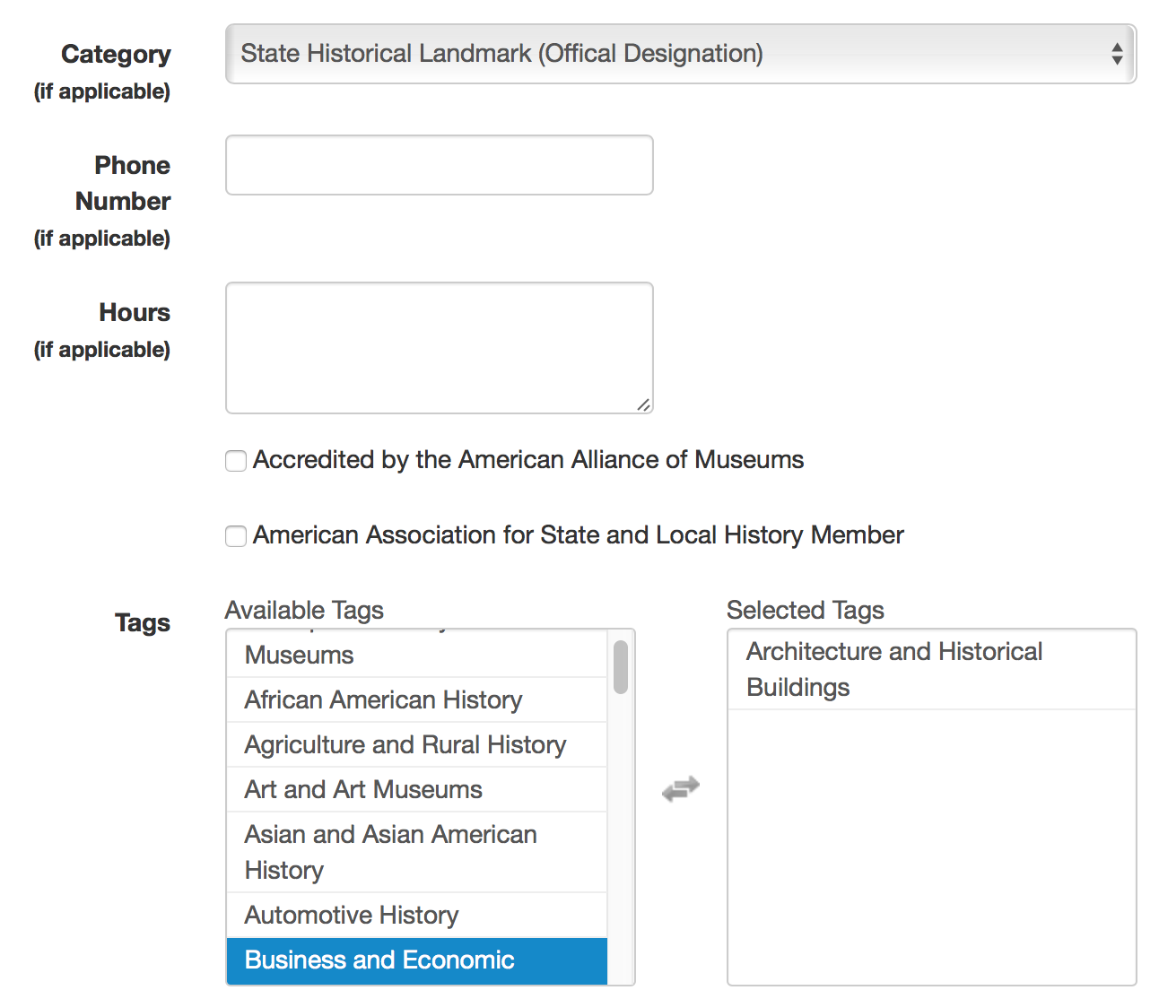
Add Additional Information  After the tags, Clio requires you to type up additional information about your site in 3-6 more detailed paragraphs. This text should be in your own words, not plagiarized from other sites. If you do use others' text, put it in quotation marks and include a citation in the section "Sources." | 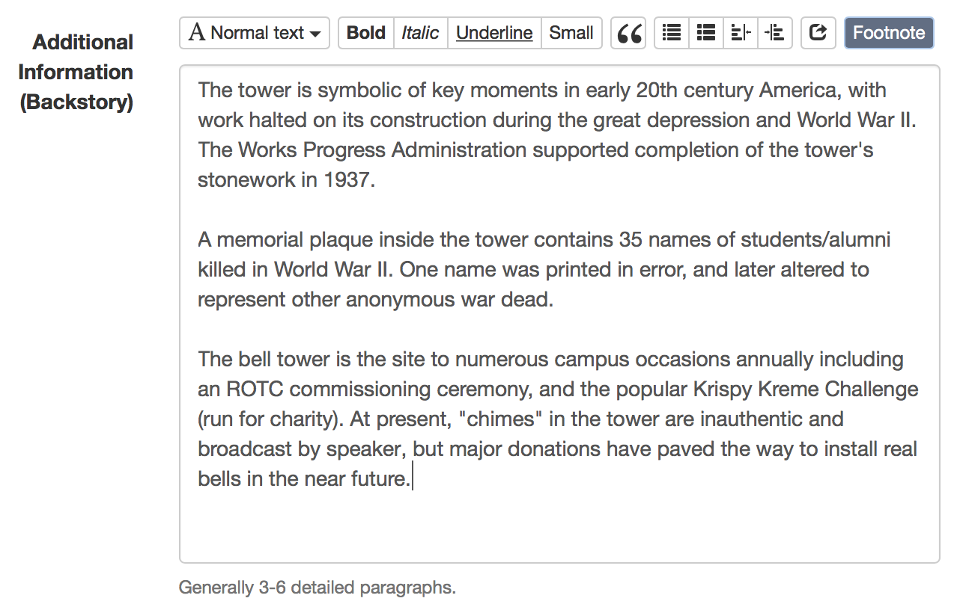
Add Photos  After sources, you can upload multiple photos of your site to provide users with additional visual details of the site. For projects in this Borchardt program, please provide at least one photo of the sites you are writing about, and ideally multiple photos for the Prague sites you are researching in person. | 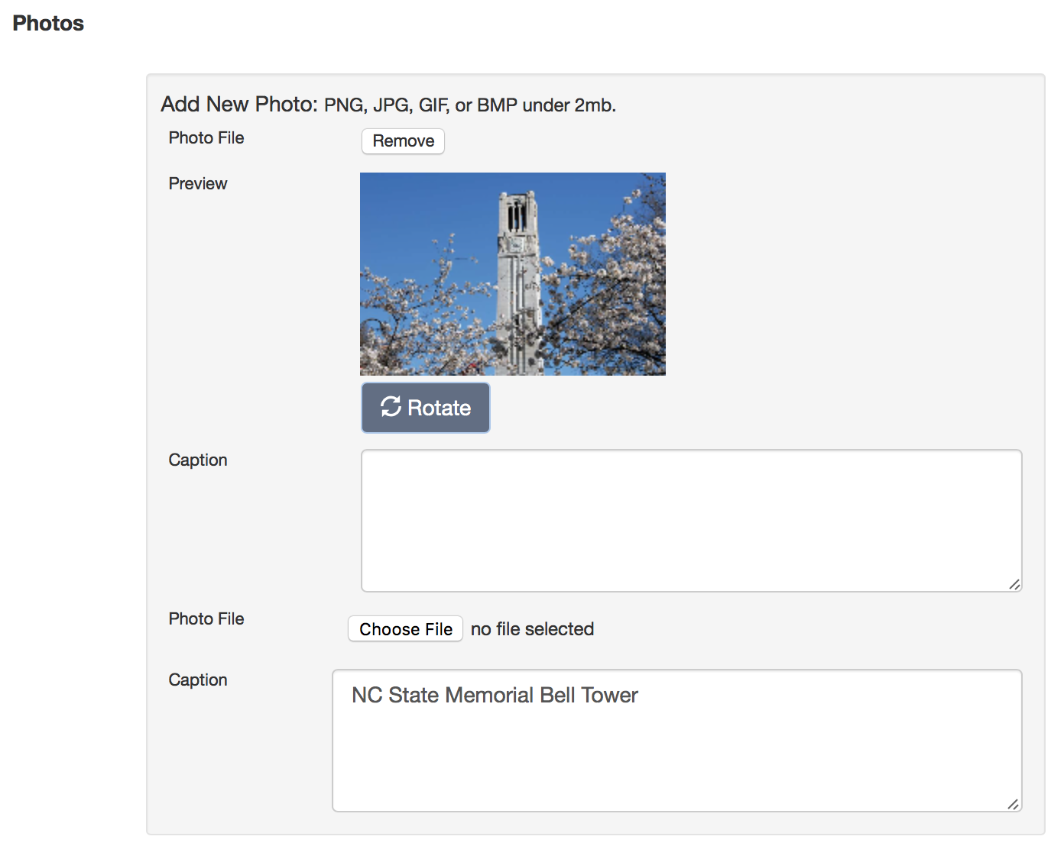

Select/Edit Street View  In the right-hand column of your entry, notice the Google Street View that is shown. This is generated from the address you provided when starting this entry. Adjust the street view by moving the arrows and dragging the image around until the site you are writing about displays well. Whatever view you leave this image on is the view that will display for readers of your entry.  If for some reason Google Street View doesn't show anything for your site, you can disable this feature and it won't show a Street View image for your entry. | 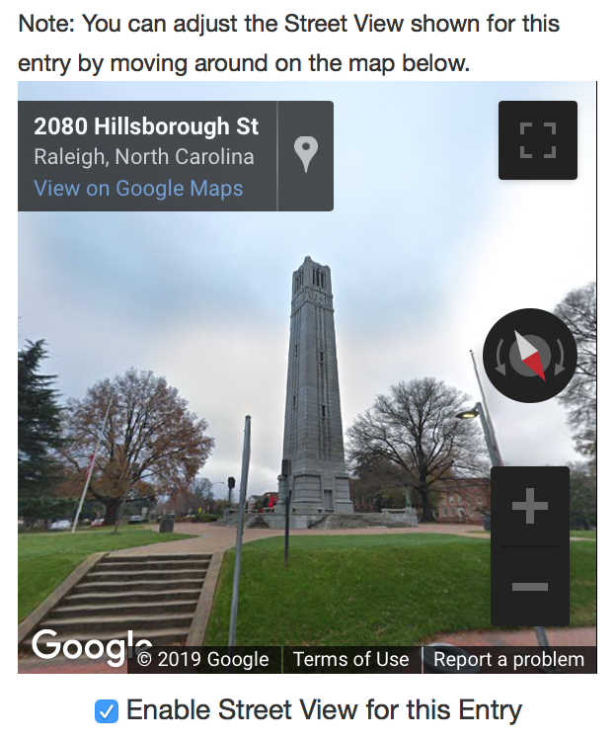
Add Links  The final thing to add to your entry are any links that will take readers to more information about your site. | 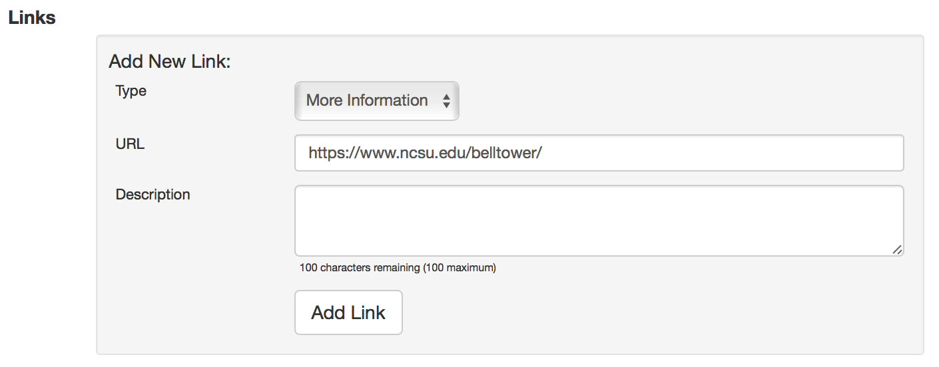
Save/Submit an Entry  To save your work, please include your name for all entries so we know who has submitted entries for these Borchardt projects. If you click "Submit for Review," the entry will be sent to the instructor's account for moderation and inclusion in the tours. If you click "Save as Draft" the entry will remain editable and show up in the instructor's cue as "In Progress." | 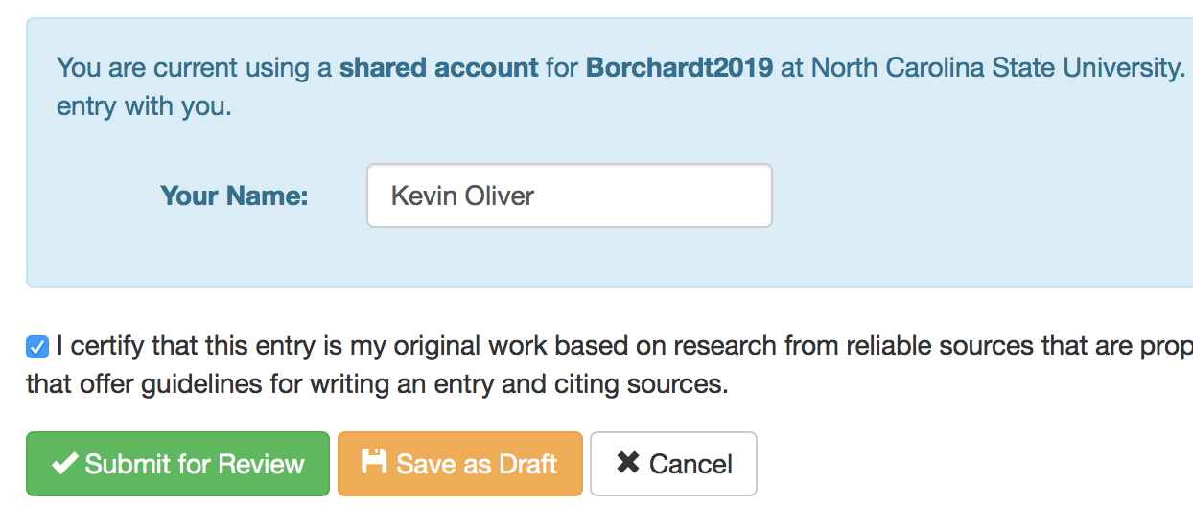
In the screen shot at right, you can see where one entry by Kevin Oliver has been "Submitted for Review" and is now in the instructor's cue for moderation and approval. | 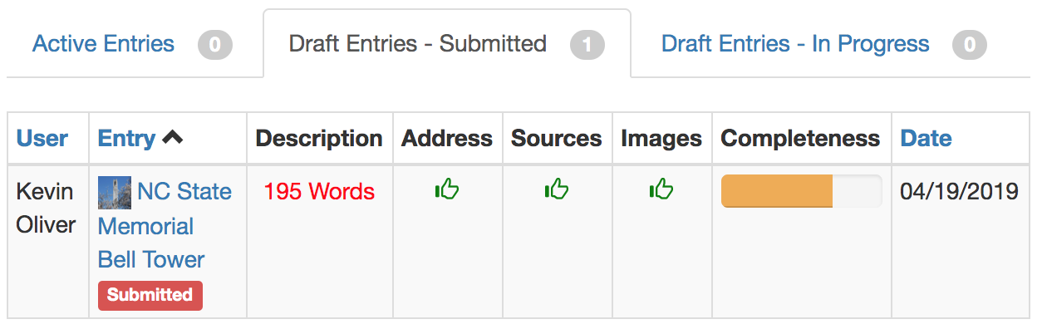

Two Entries to Complete--Contribute to Two Tours

You are asked to complete two entries for your Cultural Collections 1 Project on "Mapping Cultural Themes" with this Clio tool:
- For practice, your first entry will be created on April 27 in Raleigh on a building or historic site on NC State's main campus, to be combined into a campus tour. You may need to do some Internet research to find out enough details about your building or historic site to write up an entry. Choose an available NC State site from this shared spreadsheet to ensure no one is duplicating your site:
https://tinyurl.com/yxnybe8o
- Your second entry will be created while in Prague on our designated topic of Nazi/Soviet oppression, to be combined into a walking tour on this topic. Again, you may need to do some background research on Nazi/Soviet oppression to identify a good site to visit, photograph, and research, but once you have a site in mind, list it on this spreadsheet so no one else will duplicate your site:
https://tinyurl.com/y4zy6jej

